Assignment 9.2

**Problem Statement**

**Problem 1:**

**Create an HBase table named 'clicks' with a column family 'hits' such that it should be able to store last 5 values of qualifiers inside 'hits' column family.**

create 'clicks','hits'

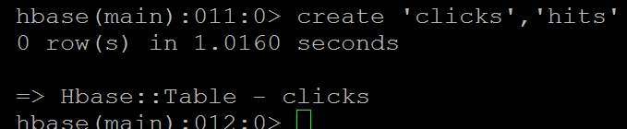

put 'clicks','192.168.56.101','hits:site_values','google'



put 'clicks','192.168.56.102','hits:site_values','yahoo'



put 'clicks','192.168.56.103','hits:site_values','stackoverflow'



put 'clicks','192.168.56.104','hits:site_values','amazon'



put 'clicks','192.168.56.105','hits:site_values','wikipedia'



**Problem 2:**

**Add few records in the table and update some of them. Use IP Address as row-key. Scan the table to view if all the previous versions are getting displayed.**

scan 'clicks'

ROW COLUMN+CELL

192.168.56.101 column=hits:site_values, timestamp=1509154182296, value=yahoo

192.168.56.102 column=hits:site_values, timestamp=1509154320955, value=yahoo

192.168.56.103 column=hits:site_values, timestamp=1509154467970, value=stack

overflow

192.168.56.104 column=hits:site_values, timestamp=1509154577228, value=wikip

edia

192.168.56.105 column=hits:site_values, timestamp=1509154677457, value=wikip

edia

5 row(s) in 0.1840 seconds

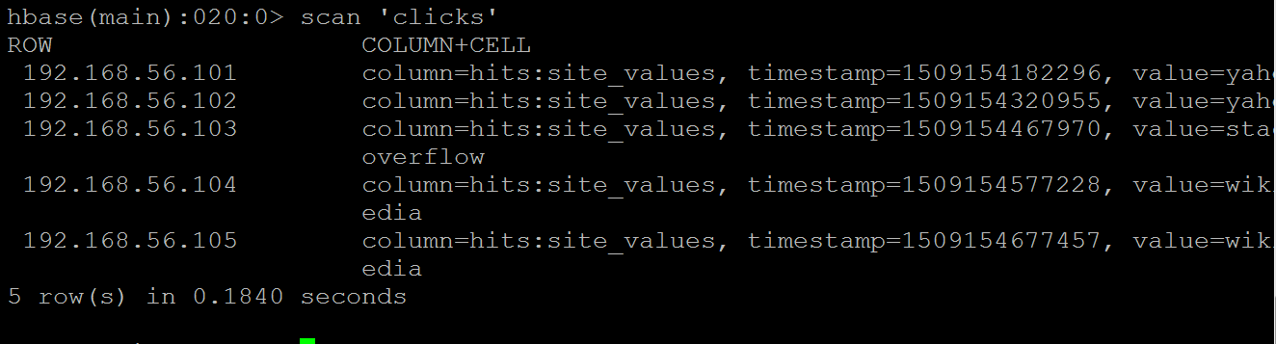

alter 'clicks', NAME=>'hits', VERSIONS=>2

put 'clicks','192.168.56.101','hits:site_values','mantra'

put 'clicks','192.168.56.101','hits:site_values','nic'

put 'clicks','192.168.56.101','hits:site_values','alibaba1'

alter 'clicks', NAME=>'hits', VERSIONS=>3

put 'clicks','192.168.56.101','hits:site_values','tojalibaba1'

put 'clicks','192.168.56.102','hits:site_values','inox'

put 'clicks','192.168.56.103','hits:site_values','yotube'

put 'clicks','192.168.56.104','hits:site_values','springsourec'

put 'clicks','192.168.56.105','hits:site_values','springboot'

scan 'clicks', {VERSIONS => 4}

ROW COLUMN+CELL

192.168.56.101 column=hits:site_values, timestamp=1509169828735, value=tojal

ibaba1

192.168.56.101 column=hits:site_values, timestamp=1509169740043, value=aliba

ba1

192.168.56.101 column=hits:site_values, timestamp=1509169706067, value=nic

192.168.56.102 column=hits:site_values, timestamp=1509171665678, value=inox

192.168.56.102 column=hits:site_values, timestamp=1509154320955, value=yahoo

192.168.56.103 column=hits:site_values, timestamp=1509171703560, value=yotub

e

192.168.56.103 column=hits:site_values, timestamp=1509154467970, value=stack

overflow

192.168.56.104 column=hits:site_values, timestamp=1509171739241, value=sprin

gsourec

192.168.56.104 column=hits:site_values, timestamp=1509154577228, value=wikip

edia

192.168.56.105 column=hits:site_values, timestamp=1509171756882, value=sprin

gboot

192.168.56.105 column=hits:site_values, timestamp=1509154677457, value=wikip

edia

5 row(s) in 0.3310 seconds

